Project Report

**Visualization tool for electric vehicle Charge and Range Analysis**

1. **INTRODUCTION** 
   1. **Overview**

The Electric Vehicle (EV) is not new, but it has been receiving significantly more attention in recent years. Advances in both EV analytics and battery technologies have led to increased automotive market share. However, this growth is not attributed to hardware alone. The modern mechatronic vehicle marries electrical storage and propulsion systems with electronic sensors, controls, and actuators, integrated closely with software, secure data transfer, and data analysis, to form a comprehensive transportation solution. Advances in all these areas have contributed to the overall rise of EV’s, but the common thread that runs through all these elements is data analytics.

* 1. **Use of this project**

The use of this project is how to increase the usage of electrical vehicle.

1. **Problem Definition & Design Thinking** 
   1. **Empathy Map**

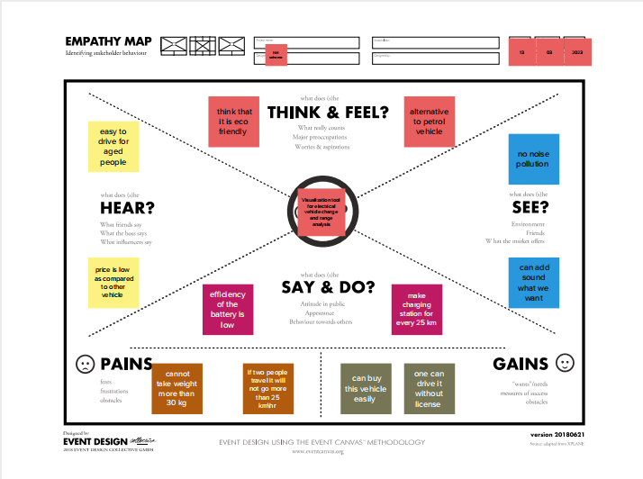

* 1. **Ideation & Brainstorming Map**

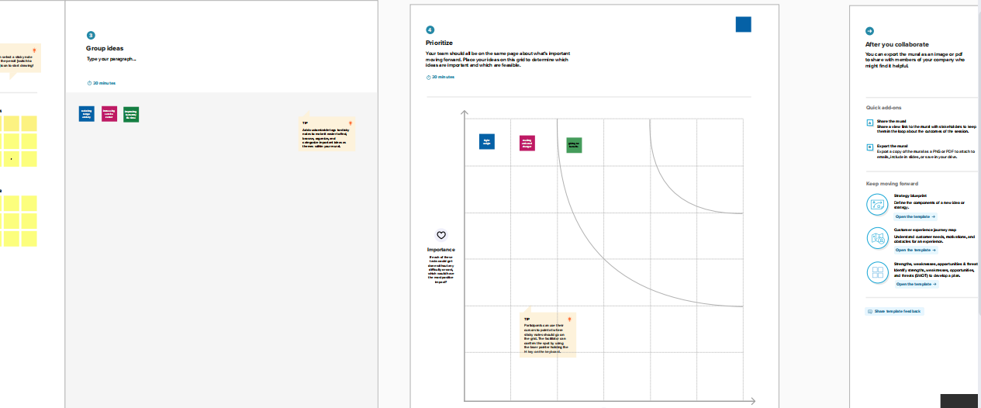

**3. RESULT**

Final findings (Output) of the project.

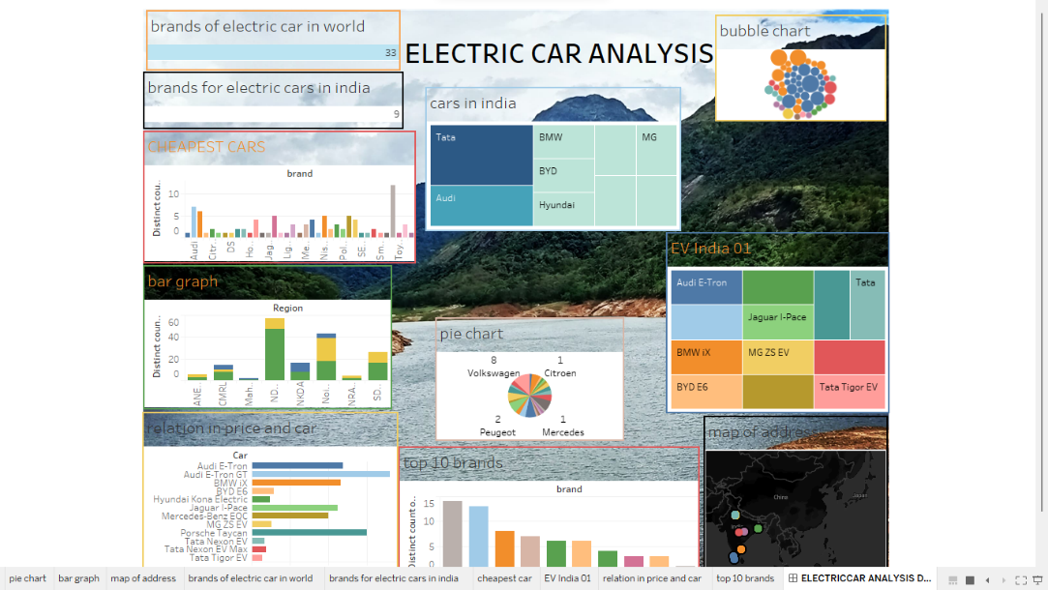

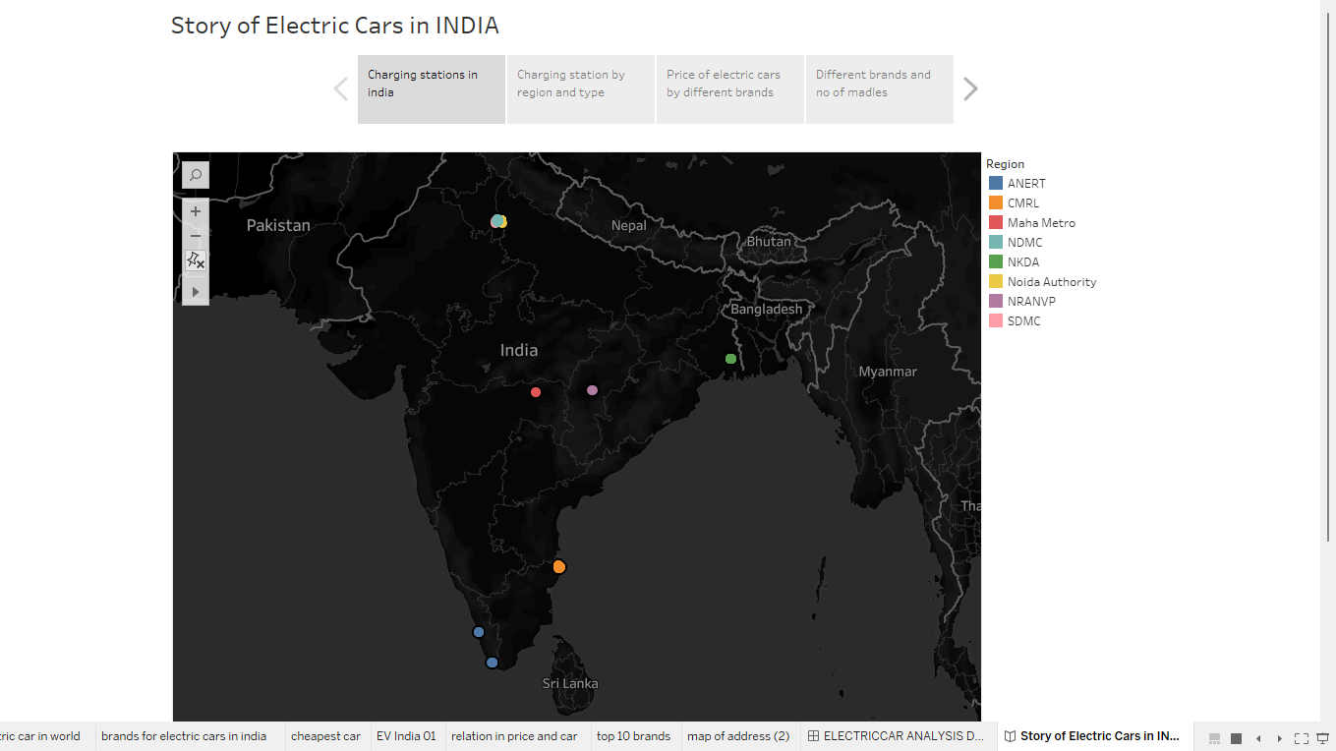

**4. ADVANTAGES & DISADVANTAGES**

List of advantages and disadvantages of the proposed solution   
• It’s expensive  
• Minimal amount of pollution.

**5 APPLICATIONS**

It is used in the electric motors, batteries, inverters, wiring and in charging stations because of its durability, malleability, reliability and superior electrical conductivity

**6 CONCLUSION**

Conclusion summarizing the entire work and findings to increasing the charging stations is the solution for increasing the usage of Electrical vehicle.

**7 FUTURE SCOPE**

Developing the design is the solution of increasing the consumption of Electrical vehicle.